Student: Gourik Narendra Patil
Assigned Pack: D5-B – Payment Webhook AI Plan

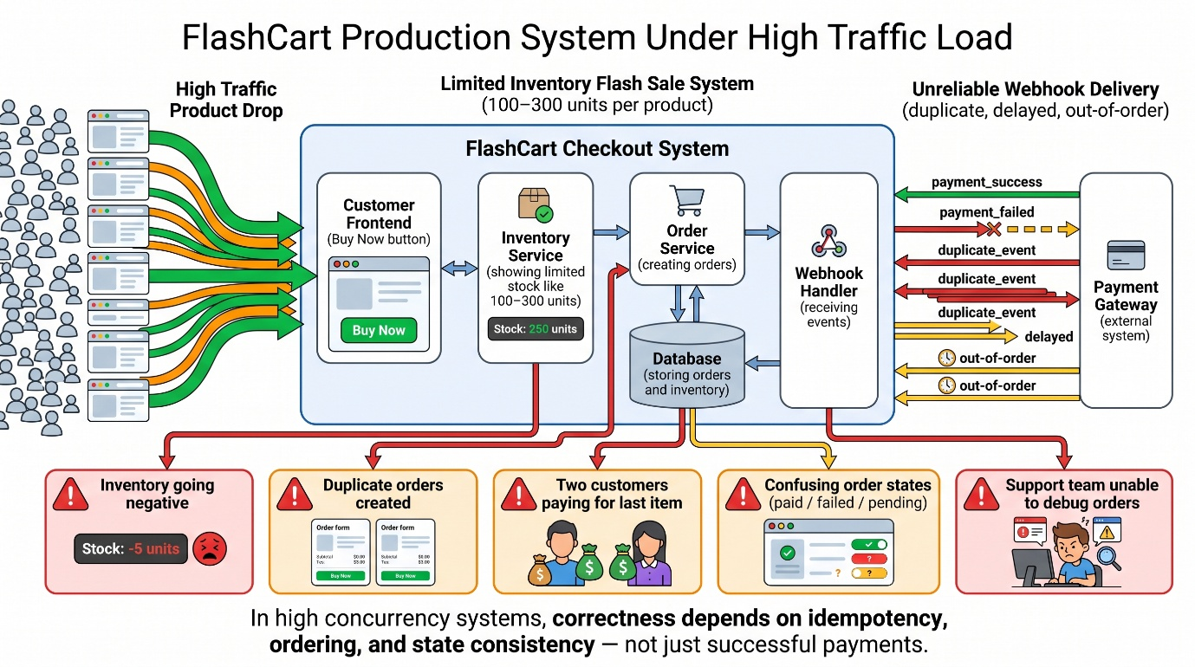

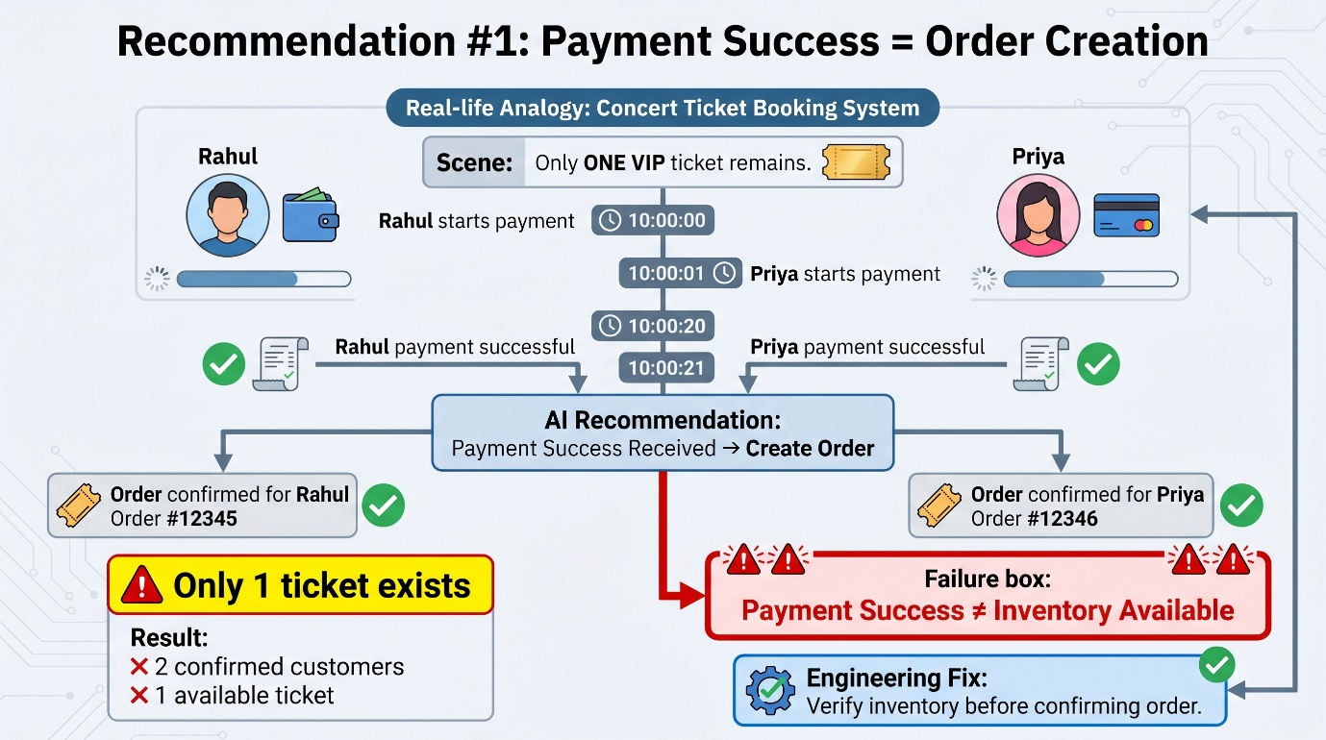
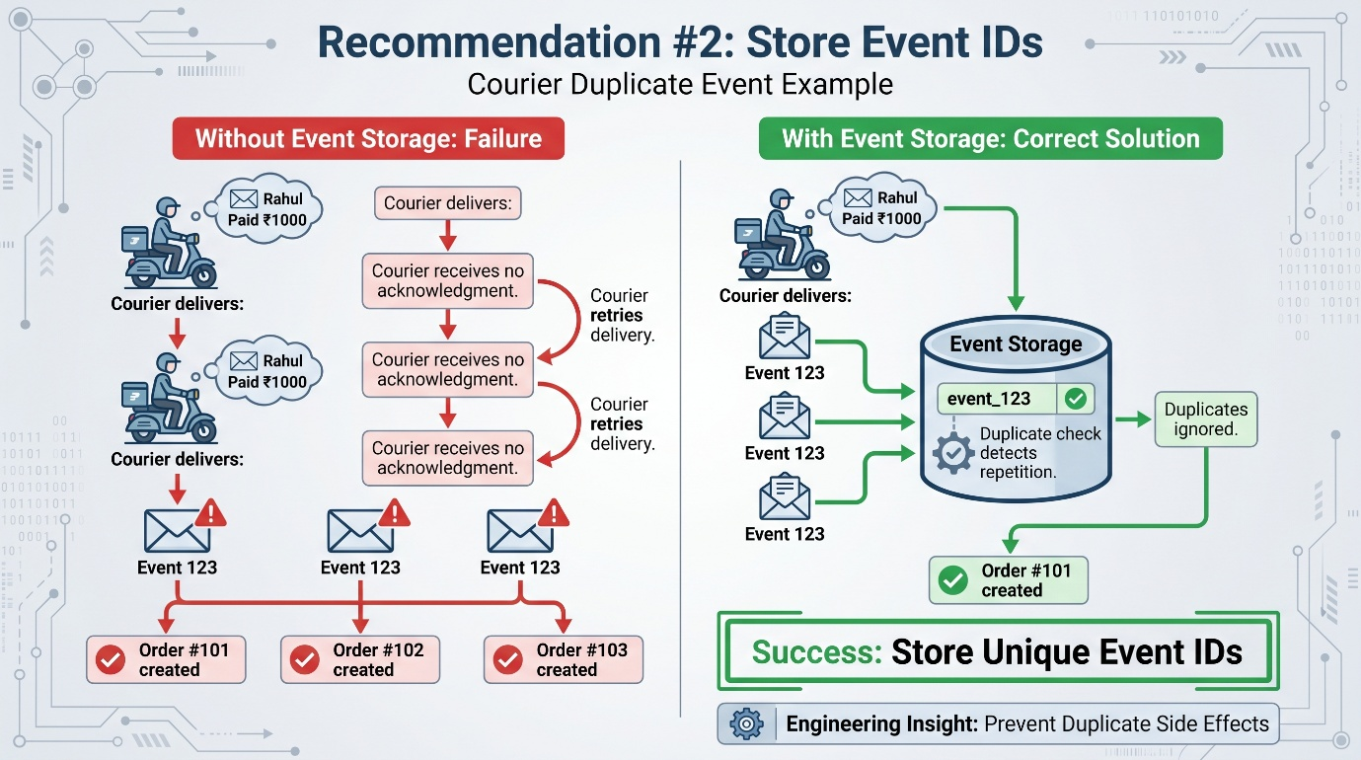

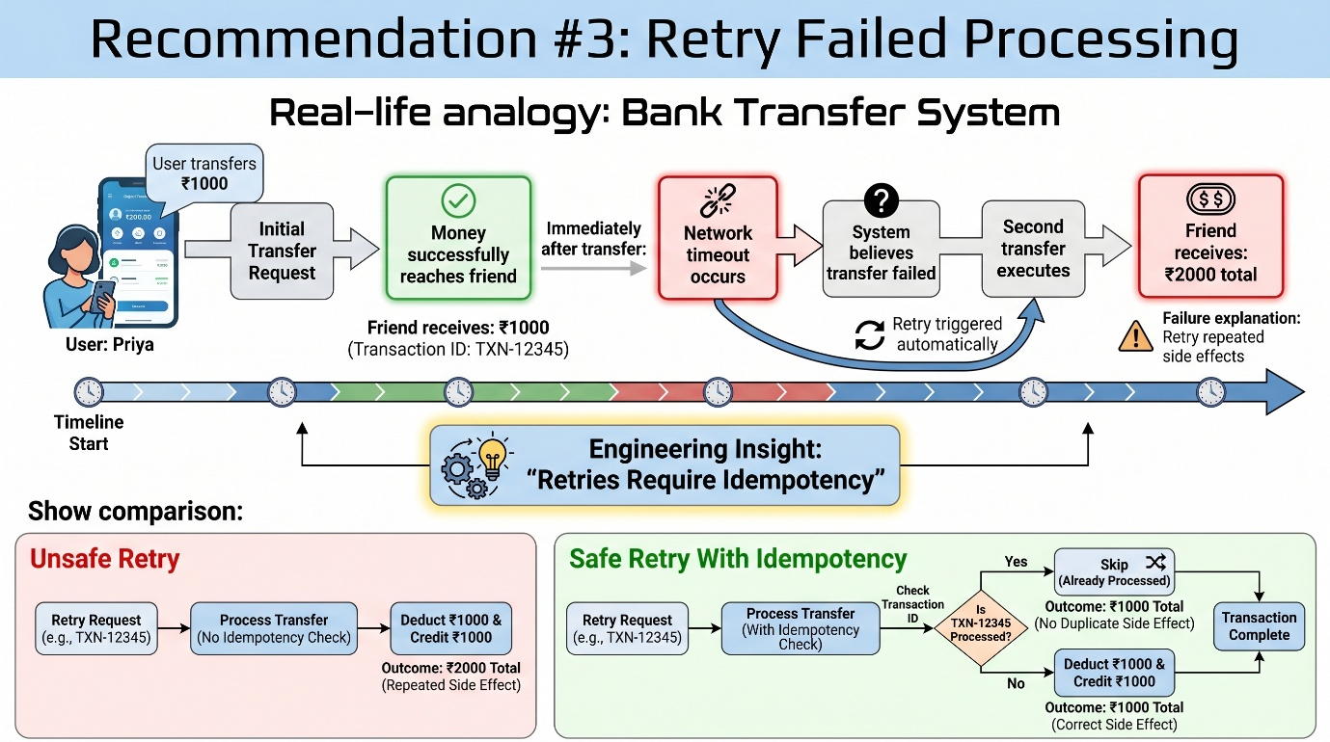
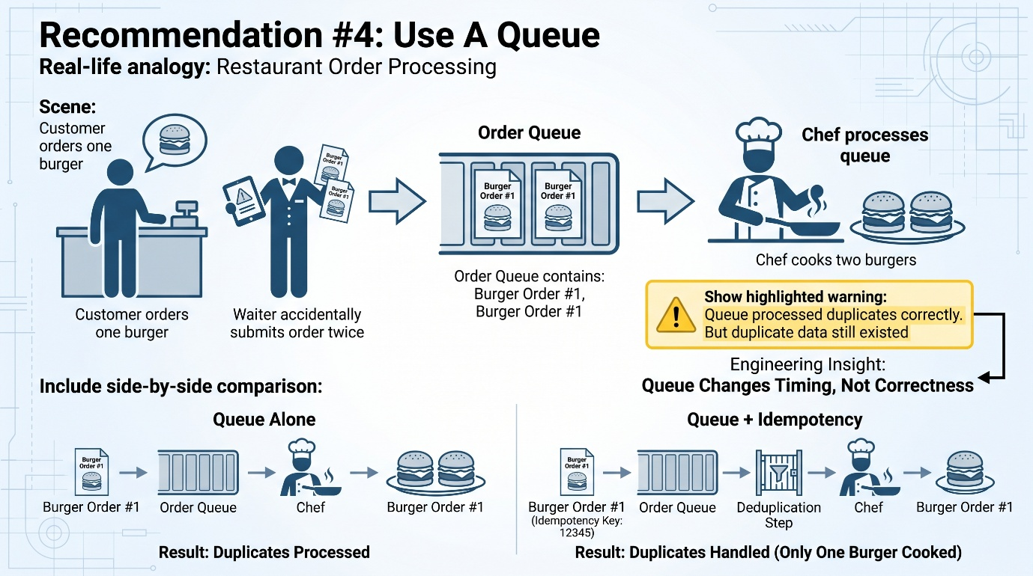

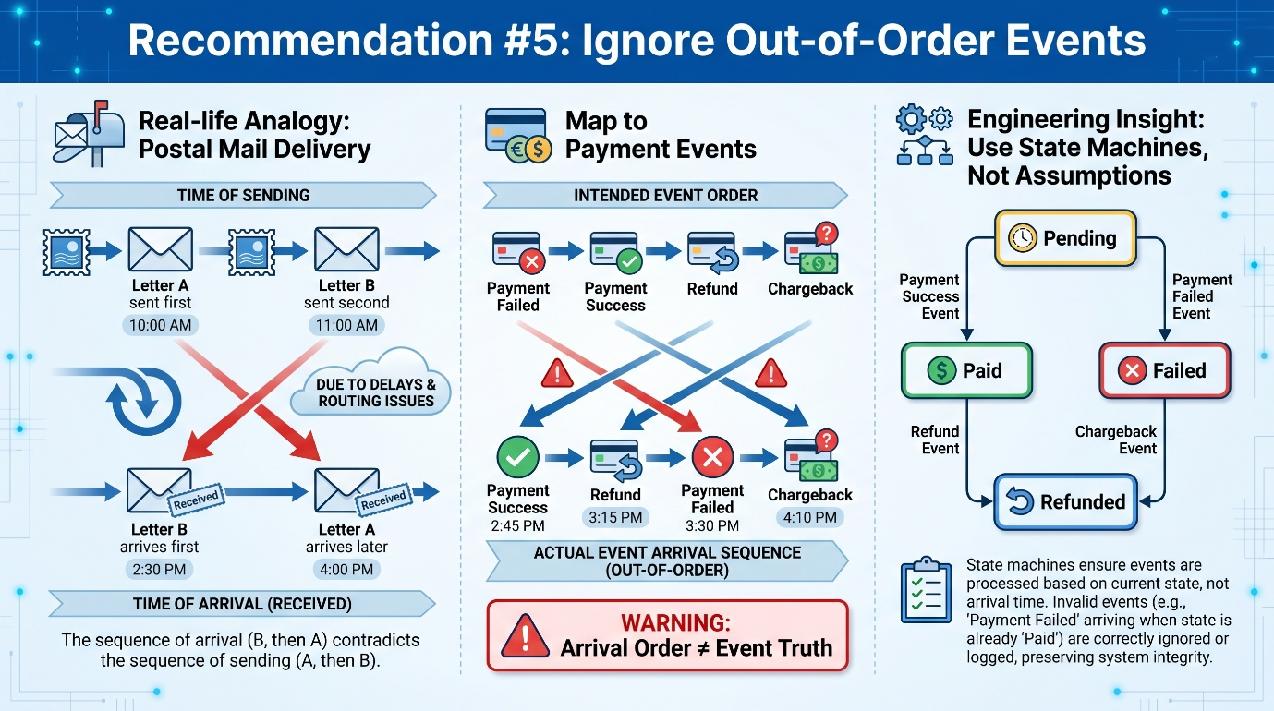

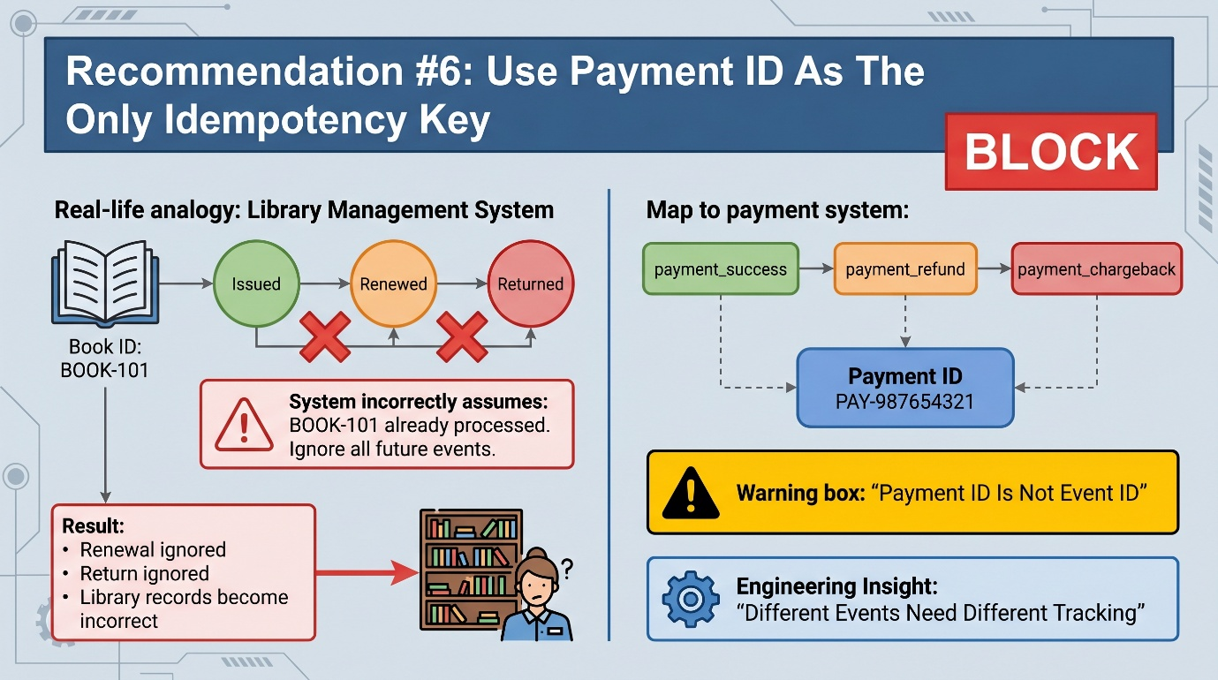

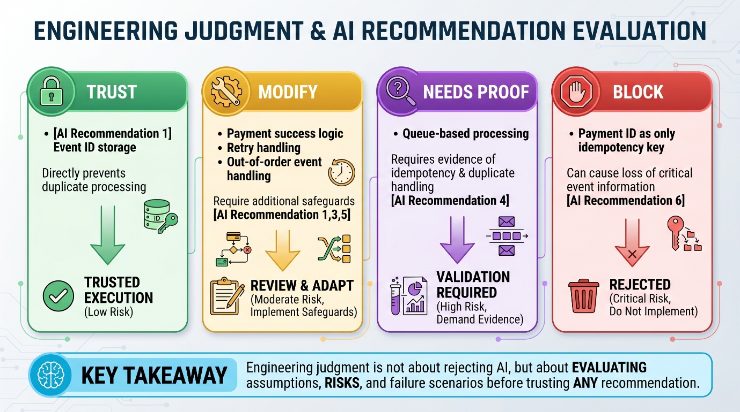

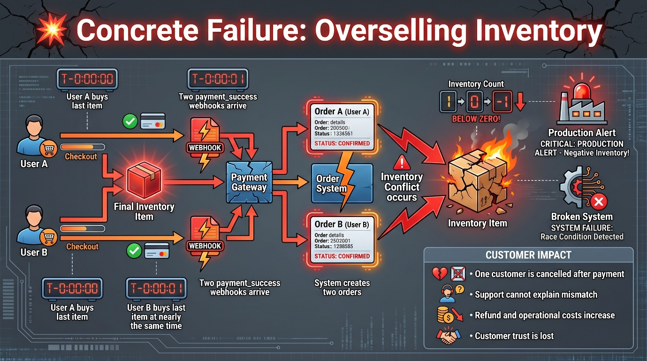

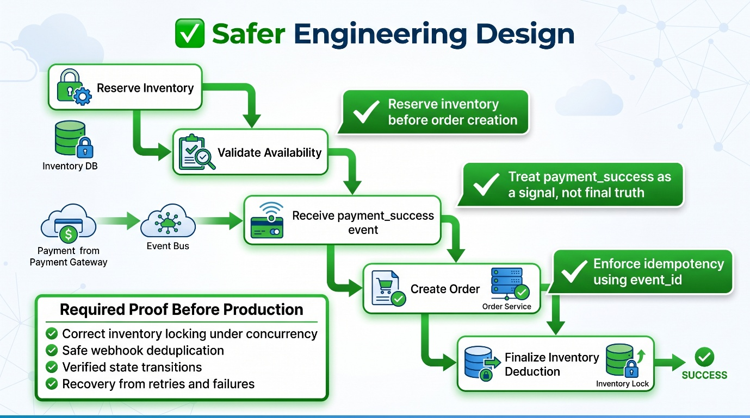

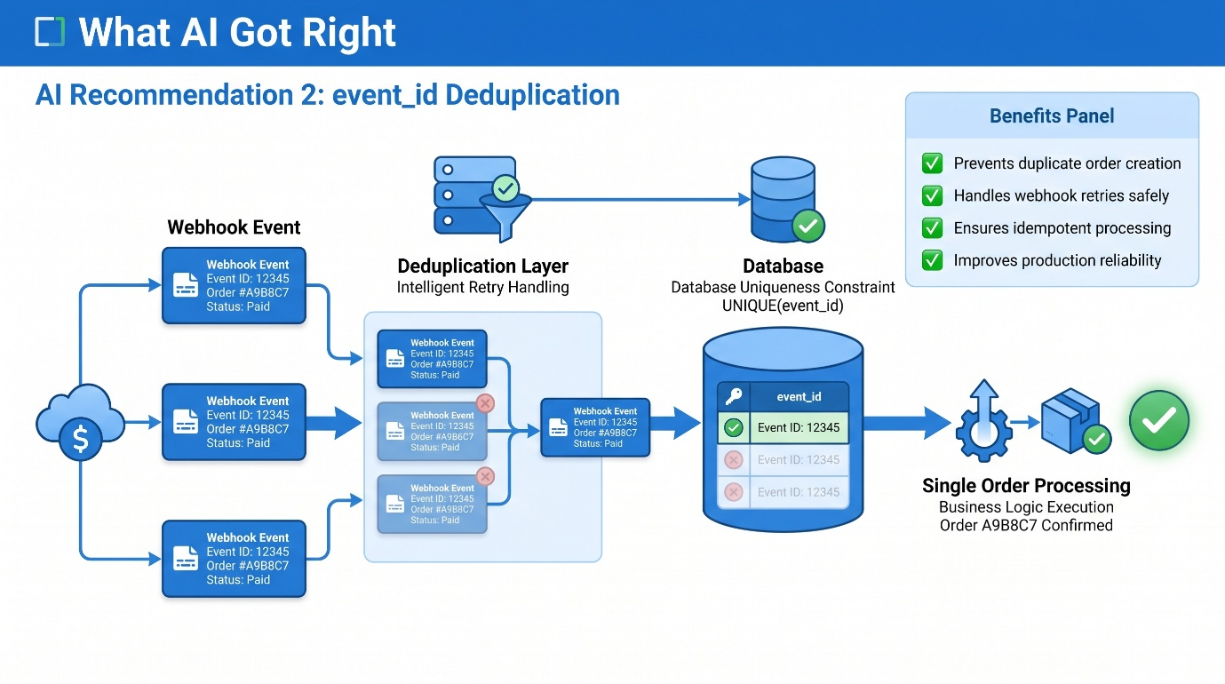

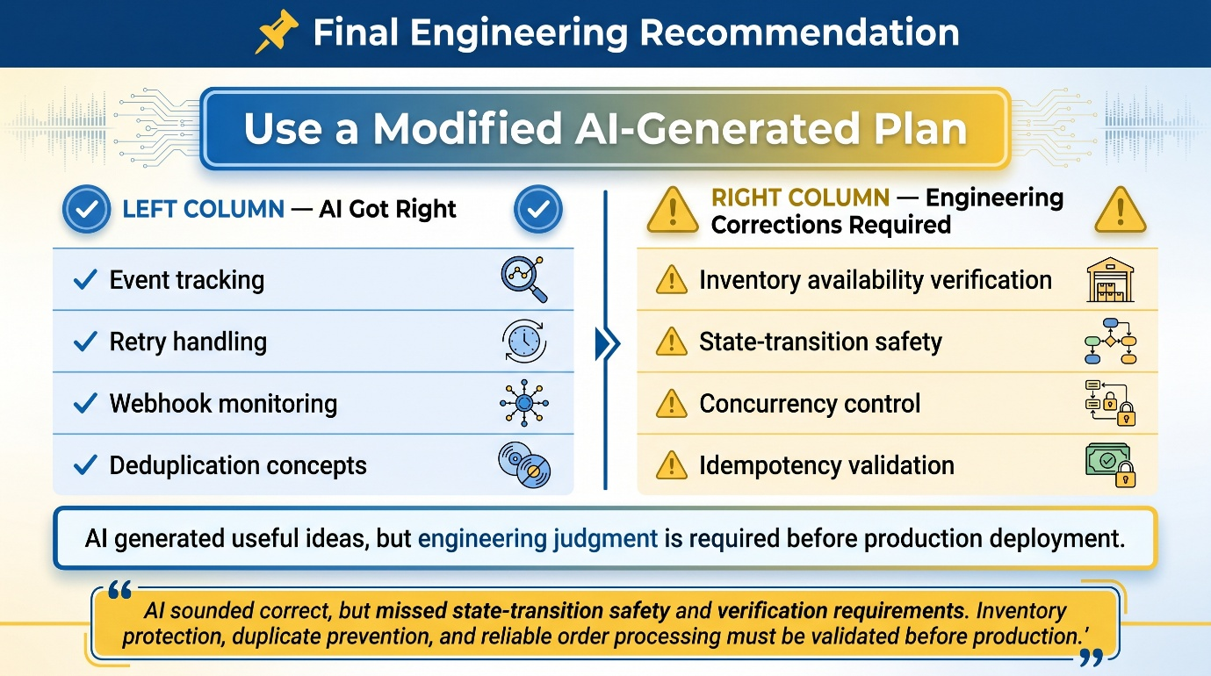

Table of Contents
1. AI Trust Decision Brief 8
1. Problem Summary 8
2. AI Recommendation Decision Table 9
3. Most Dangerous Recommendation 10
4. Useful But Incomplete Recommendation 10
5. One Recommendation Trusted For V1 11
6. Safer V1 Plan 11
7. State / Side Effect Protection 12
8. What Not To Build 13
9. Evidence Needed Before Trust 13
10. Final Founder Recommendation 14
11. Final One-Liner 14
2. AI Recommendation Classification Matrix 15
Useful AI Ideas 15
Unsafe AI Claims 15
Proof Required 15
3. Safer Engineering Action Plan 16
Recommended V1 Action 16
Modify / Block List 16
Production Failure Prevented 16
Verification Required 17
Founder-Ready Recommendation 17

1. AI Trust Decision Brief
Student: Gourik Narendra Patil
Assigned Pack: D5-B – Payment Webhook AI Plan

1. Problem Summary
FlashCart is a high-traffic e-commerce system with limited inventory drops, where thousands of users compete for 100–300 units. This has led to production issues such as duplicate webhook processing, negative inventory, multiple customers purchasing the last available item, and inconsistent order states.
The AI-generated plan attempts to improve reliability using webhook event tracking, retries, queue-based processing, and idempotency mechanisms. My responsibility is to evaluate which recommendations are safe for a one-week v1 release, which require modification, and which are unsafe without further evidence.
The key engineering concerns are:
- Inventory correctness under concurrency
- Webhook idempotency
- Event ordering reliability
- Safe state transitions between payment and order creation

2. AI Recommendation Decision Table

# | AI Recommendation | Decision | Why | Concrete Failure If Wrong | Safer Action / Evidence Needed
1 | Trust payment_success webhook as order truth | Modify | Payment success does not guarantee inventory availability | Two users can be confirmed for the last item | Reserve inventory before order creation
2 | Store gateway event IDs | Trust | Prevents duplicate webhook processing | Duplicate orders and duplicate inventory deduction | Store event_id with DB unique constraint
3 | Retry failed webhook processing | Modify | Retries are useful but unsafe without idempotency | Same operation executed multiple times | Retry only after idempotent processing
4 | Process webhooks in a queue | Needs Proof | Queue improves throughput but not correctness | Duplicate events still processed | Prove consumer idempotency + failure handling
5 | Ignore out-of-order events | Modify | Some late events are valid state transitions | Refunds or chargebacks may be ignored | Use explicit state machine transitions
6 | Use payment_id as only idempotency key | Block | Different event types share same payment_id | Important events like refund ignored | Use event_id for processing idempotency

3. Most Dangerous Recommendation
Recommendation:
Use payment_id as the only idempotency key.
Why it sounded correct
Payment IDs are assumed to be unique per transaction, so it appears safe for deduplication.
Failure Timeline
First: Payment success webhook is processed with payment_id = P123.
Then: System stores P123 as processed.
Then: A refund or chargeback event arrives with the same payment_id.
Then: System ignores it, assuming it is duplicate.
Production breaks because:
Valid financial lifecycle events are skipped.
Customer / support impact:
- Refunds not reflected in system
- Financial records become inconsistent
- Support cannot explain payment state mismatch
What I Would Do Instead
- Use event_id for webhook idempotency
- Use payment_id for transaction grouping only
- Enforce state validation before applying transitions

4. Useful But Incomplete Recommendation
Recommendation: Retry failed webhook processing three times
What was useful
Retries help recover from temporary network failures and database downtime.
What was missing
Retries may repeat side effects if idempotency is not enforced.

Modified Version
Retries should only be applied after:
- event-level idempotency is implemented
- state transitions are validated
- database transactions are safe

5. One Recommendation Trusted For V1
Recommendation: Store gateway event IDs
Why it is safe enough
Duplicate webhook delivery is a real and frequent issue in payment systems. Event ID tracking is a proven and lightweight safeguard.
Boundary condition
- event_id must be stored in a relational database
- must have a UNIQUE constraint
- must be checked before processing webhook

6. Safer V1 Plan
Inventory Ownership
Relational database is the single source of truth.
Checkout / Reservation State
- CREATED
- RESERVED
- PAID
- FAILED
- EXPIRED

Payment State
- PENDING
- PAID
- FAILED
- REFUNDED
Order Confirmation Rule
Order is confirmed only if:
- Payment is successful
- Inventory is reserved
- Inventory is available
Duplicate / Retry Handling
- Store unique event_id
- Ensure idempotent webhook processing
- Use transactional updates for state changes
Expiration / Release Behavior
- Expired reservations automatically release inventory
Customer / Support Visibility
Every checkout must clearly expose:
- RESERVED
- PAID
- FAILED
- EXPIRED
- REFUNDED

7. State / Side Effect Protection
What must NOT happen twice
- Order creation
- Inventory deduction
- Payment processing
Protected Transition
RESERVED → PAID → ORDER_CONFIRMED
Protection Mechanisms
- UNIQUE(event_id) constraint
- Database transactions
- State validation before transitions
What breaks under concurrency
- Duplicate orders
- Negative inventory
- Double payment processing

8. What Not To Build
Not In V1 | Why Not Now | Risk
Full microservices architecture | Too complex for 1 week | Delays delivery
Event sourcing system | Over-engineering | Hard to maintain
Dedicated inventory service | Small team constraint | Operational overhead
Cache as source of truth | Unsafe for inventory | Data inconsistency

9. Evidence Needed Before Trust
Claim | Evidence Needed
Queue improves reliability | Duplicate-event load testing
Out-of-order events can be ignored | Gateway documentation
payment_id prevents duplicates | Tests with refund + chargeback cases

10. Final Founder Recommendation
Decision: Use modified AI plan

Founder Update
The AI plan contains useful ideas such as event tracking and retry handling. However, it is unsafe as written because it assumes inventory availability, correct event ordering, and idempotency without verification.
I recommend a modified v1 system that enforces:
- event-level idempotency
- inventory reservation before order confirmation
- explicit state transitions
- safe retry handling
- clear customer-visible order states

11. Final One-Liner
AI sounded correct, but it missed state-transition safety and event-level idempotency, so I changed the design to ensure inventory protection, prevent duplicate side effects, and guarantee reliable order processing.

2. AI Recommendation Classification Matrix
Student: Gourik Narendra Patil
Variant ID: D5-B

AI Recommendation | Classification | Evidence / Risk | Safer Boundary
Payment success as order truth | Modify | Ignores inventory constraints | Validate reservation first
Store gateway event IDs | Trust | Prevents duplicates | DB unique constraint
Retry webhook processing | Modify | Can repeat side effects | Idempotent retry only
Queue processing | Needs Proof | Does not ensure correctness | Prove idempotent consumer
Ignore out-of-order events | Modify | Valid events may be lost | State machine logic
Payment ID as only key | Block | Skips lifecycle events | Use event_id

Useful AI Ideas
- Event-based deduplication
- Retry mechanism concept
- Async processing consideration

Unsafe AI Claims
- Payment success equals order finality
- payment_id alone ensures idempotency
- Event order can be ignored safely

Proof Required
- Queue failure simulation tests
- Duplicate webhook injection tests
- Event ordering behavior documentation

3. Safer Engineering Action Plan
Student: Gourik Narendra Patil
Variant ID: D5-B

Recommended V1 Action
Implement:
- event-level idempotency
- inventory reservation before payment confirmation
- strict state transitions
- safe retry handling
- relational DB as single source of truth

Modify / Block List
AI Suggestion | Action | Why
Payment success creates order | Modify | Inventory must be verified first
Retry processing | Modify | Needs idempotency
Queue processing | Needs Proof | Does not ensure correctness
Ignore out-of-order events | Modify | Can lose valid transitions
Payment ID as key | Block | Breaks lifecycle tracking

Production Failure Prevented
- Two users buy last item simultaneously
- Both payments succeed
- Two orders are created
- Inventory goes negative
- System shows inconsistent state

Verification Required
Check | Evidence Needed
Queue safety | Load + duplicate tests
Retry safety | Idempotency validation
Event ordering | Gateway documentation

Founder-Ready Recommendation
The AI plan contains useful operational improvements, but it is not safe for direct production use. Event-based deduplication is valid and should be implemented. However, payment success must not directly create orders without inventory verification. Queue processing requires proof of correctness under duplicate and failure conditions. For v1, the system should prioritize inventory protection, event-level idempotency, transactional safety, and clear state transitions.

